**Types of SQL JOINs**

* **(INNER) JOIN**: Returns records that have matching values in both tables

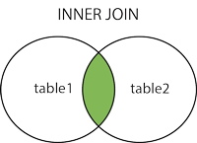

SELECT column_name(s)  
FROM table1  
INNER JOIN table2ON table1.column_name = table2.column_name;

* **LEFT (OUTER) JOIN:** Returns all records from the left table, and the matched records from the right table

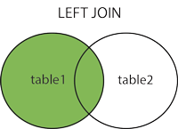

SELECT column_name(s)  
FROM table1  
LEFT JOIN table2ON table1.column_name = table2.column_name;

* **RIGHT (OUTER) JOIN:** Returns all records from the right table, and the matched records from the left table

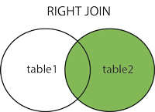

SELECT column_name(s)  
FROM table1  
RIGHT JOIN table2ON table1.column_name = table2.column_name;

* **FULL (OUTER) JOIN:** Returns all records when there is a match in either left or right table

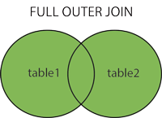

SELECT column_name(s)  
FROM table1  
FULL OUTER JOIN table2ON table1.column_name = table2.column_nameWHERE condition;

**View**

A view contains rows and columns, just like a real table. The fields in a view are fields from one or more real tables in the database.

You can add SQL statements and functions to a view and present the data as if the data were coming from one single table.

**Create:-**

CREATE VIEW view_name AS  
SELECT column1, column2,...  
FROM table_name  
WHERE condition;

**Update:-**

CREATE OR REPLACE VIEW view_name AS  
SELECT column1, column2, ...  
FROM table_name  
WHERE condition;

**Drop/Delete:-**

DROP VIEW view_name;

**Subqueries**

A Subquery is a query within another SQL query and embedded within the WHERE clause.

**1.Select:-**

SELECT column_name

FROM table_name

WHERE column_name expression operator

**2.Insert:-**

SELECT column_name

FROM table_name

WHERE column_name expression operaor

**3.Update:-**

UPDATE table

SET column_name = new_value

WHERE VALUE OPERATOR

**4.Delete:-**

DELETE FROM table_name

WHERE VALUE OPERATOR